Predefined Email Component For Joomla!

Software Requirements Specification

Version 1.0

Malaka G.L.

110348H

CSE ’11 Batch

Revision History

|  |  |  |  |
| --- | --- | --- | --- |
| **Date** | **Version** | **Description** | **Author** |
| 08/07/2014 | 1.0 | Initial software requirements for the project | Malaka G.L. |
|  |  |  |  |
|  |  |  |  |
|  |  |  |  |

Table of Contents

1. Introduction 3

1.1 Purpose 3

1.2 Scope 3

1.3 Definitions, Acronyms, and Abbreviations 3

1.4 References 3

1.5 Overview 4

2. Overall Description 4

3. Specific Requirements 4

3.1 Functionality 4

3.1.1 Component menu item in Joomla CMS back end 4

3.1.2 Email sent confirmation notification in front end 5

3.2 Usability 5

3.3 Reliability 5

3.4 Performance 5

3.5 Supportability 6

3.6 Design Constraints 6

3.7 On-line User Documentation and Help System Requirements 6

3.8 Purchased Components 6

3.9 Interfaces 6

3.9.1 User Interfaces 6

3.9.2 Software Interfaces 7

3.9.3 Communications Interfaces 7

3.10 Licensing Requirements 7

3.11 Legal, Copyright, and Other Notices 7

3.12 Applicable Standards 7

# Introduction

Joomla is a famous and rapidly spreading Content Management System. It follows a method such that anyone with a little amount of web developing knowledge can develop a website easily. For this it uses an architecture composed with components and modules. This components and modules are very generic. So every basic function of a website can be accomplished by assigning a module or a component. Components provide very basic functionalities while modules provide extended features. Moreover it uses extensions to provide more and more easy functionalities. These extensions are developed by the users all around the world to overcome the problems arise as they use the system. Since this is a Free and Open Source Software project anyone can contribute to the development and all the added features are available for anyone who is in interest.

## Purpose

The purpose of this software project is to develop a component for the Joomla CMS. Using this component, web developers can define emails to be sent to his website users. Once a defined trigger event is triggered in the website, the relevant mail is sent, automatically, using the trigger arguments. This will make the web developers’ lives easy, since they do not need to define and set triggers at each place they want to set an email notification.

## Scope

This component basically should provide an interface for web to define the emails. It also should provide the website user a simple interface only to provide notifications. In this component website user has nothing to do directly with the component. Web developer interacts with the component basically. He configures the component. So the GUI is needed only for site back end. For front end also a notification can be implemented to inform the web site user that a mail was sent.

## Definitions, Acronyms, and Abbreviations

CMS - Content Management System

FOSS - Free and Open Source Software

GUI - Graphical User Interface

## References

1. What is a component in Joomla! <http://docs.joomla.org/What_are_components%2C_modules%2C_mambots_and_plugins%3F>

2. Project idea <http://docs.joomla.org/GSOC_2014_Project_Ideas#Project:_Component_for_managing_predefined_emails>

## Overview

This document includes all the requirement details that any stakeholder should know regarding this project. Stakeholders of this project are all users in Joomla community and project supervisors in Department of Computer Science Engineering.

# Overall Description

Predefined email component for Joomla is a component which is making the web developer’s life easy. Basically it defines emails that he should send his web site visitors to confirm their registration, password change notifications, updating details and so on. Once he defines a generic email template and defines triggers to send that email, he is done with initiating an instance from the component. Then when a defined trigger event is triggered, the component itself will take the control and proceed to send the relevant email to the relevant email address.

Furthermore, the component should provide the facility to the web developer to define some notification to the website visitors also. That may be a notification like “Your confirmation email was sent”. The web developer should have the option to enable or disable this.

The objective of this project is to create a generic component for this task. Generic component is in the sense to replace all the prevailing extensions which have been developed for this purpose.

# Specific Requirements

## Functionality

Functionality of the component has two main sides. One is in the back end while the other is in the front end of the site. At the back end of the site the component should help the web developer by making his developing task easy. While at the front end the component should help the website visitor by providing him adequate details regarding the functionality of the component.

### Component menu item in Joomla CMS back end

This menu item will provide the web developer an ease to create a component. Once this button is pressed the web developer will be directed to an interface where he can define the destination address and the body of an email message. This destination address will be a variable most of the time and the body of the message also may include variables.

### Email sent confirmation notification in front end

Once an email was sent automatically the system should display a notification to the web site visitor when it is necessary. Necessary is in the sense that the web site user should not be informed when a password changed email was sent to the user. In such occasions the notification is not necessary.

## Usability

This will be added as a component in Joomla CMS. So it will behave in the same way that any Joomla component will behave. Users, i.e. web developers, will not need a special training for using this component. However some kind of help documentation will provide the training when necessary. Still that would take maximum one hour or two.

Web developers use a lot of time currently to accomplish the task which is going to fulfill by this component. Even there some extensions which do the same work they are not reliable much as a Joomla in built component. So, it would save a lot of time and attract more and more people to use the Joomla CMS.

## Reliability

* **Availability:** Component is available once you install Joomla along with it. Since it is more than an extension all the successive versions of Joomla will include this component until the functionality of this component fade away or another component to achieve that is created. In case of the service supported by the component also remains, reliable and fully available as long as the other functionalities of the site available.
* **Mean Time Between Failures:** If the component get corrupted the whole site must be at risk, i.e. some kind of hidden vulnerability is within the system which can damage the components of the system. That may be problem to the whole system. In case of the service supported by the component, the service will be available as long as the site is available.
* **Mean Time To Repair:** The same time needed to amend the site once it is got down.
* **Accuracy:** Accuracy of the component behavior is reliable. It stores all the data regarding predefined email details to the database and triggers on events approved by the web developer. As long as there is no vulnerability in the system, the component will work fine.

## Performance

Response time for an event by the component will depend on the capability of the domain. However in a normal server the component action would be done within maximum of 3 seconds, i.e. sending an email once a trigger is set on.

Predefined email details will be stored in the website database and will be imported once an event is created. The memory taken to this storage will not exceed a megabyte even for hundred predefined emails. But fortunately, a site which needs hundred predefined emails will be very rare.

## Supportability

* All the coding should follow the coding style followed in Joomla coding structure.
* The component’s directory structure must be according to as defined in the Joomla Developer Documentation.
* All functions, classes must be properly commented for documentation.

## Design Constraints

* All the coding should be done using PHP.
* Database system used in Joomla is MySQL.
* For ease of coding I am going to use JetBrains IDE.
* Rational Unified Process will be used for the development process.

## On-line User Documentation and Help System Requirements

Online user documentation has to be provided for new users.

## Purchased Components

No purchased components will be used for this component.

## Interfaces

### User Interfaces

User interface should be similar to the structure shown below.

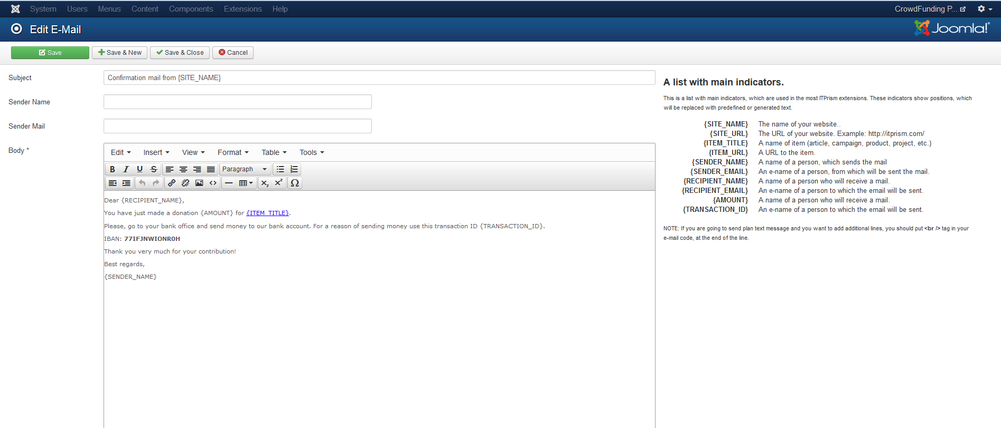

### Software Interfaces

This component should provide an interface to communicate with other extensions in order to help the developers to improve the usability of Joomla.

### Communications Interfaces

The component needs to communicate with the supporting extensions to provide a better and enhanced usability. For this, some excessive methods and enough accessibility for those methods should be provided.

## Licensing Requirements

Since this is a FOSS, no need to have license to use.

## Legal, Copyright, and Other Notices

This component belongs to FOSS category and anyone with interest will see the code and change it for th betterment of the software.

## Applicable Standards

Coding should follow the standard Joomla development coding style. Since this is a contribution to FOSS, it is necessary to be tidy and clean.